**Welcome Screen Activity**

After the completion of the signing in or singing up process the user precedes to a welcome screen that introduce the application and walk the user through the features of the application. The activity is designed to give a simple yet clear introduction to the application, the user can move between the screens by simply scrolling right and left or by clicking the next and previous buttons. a UML class diagram is shown in figure x.

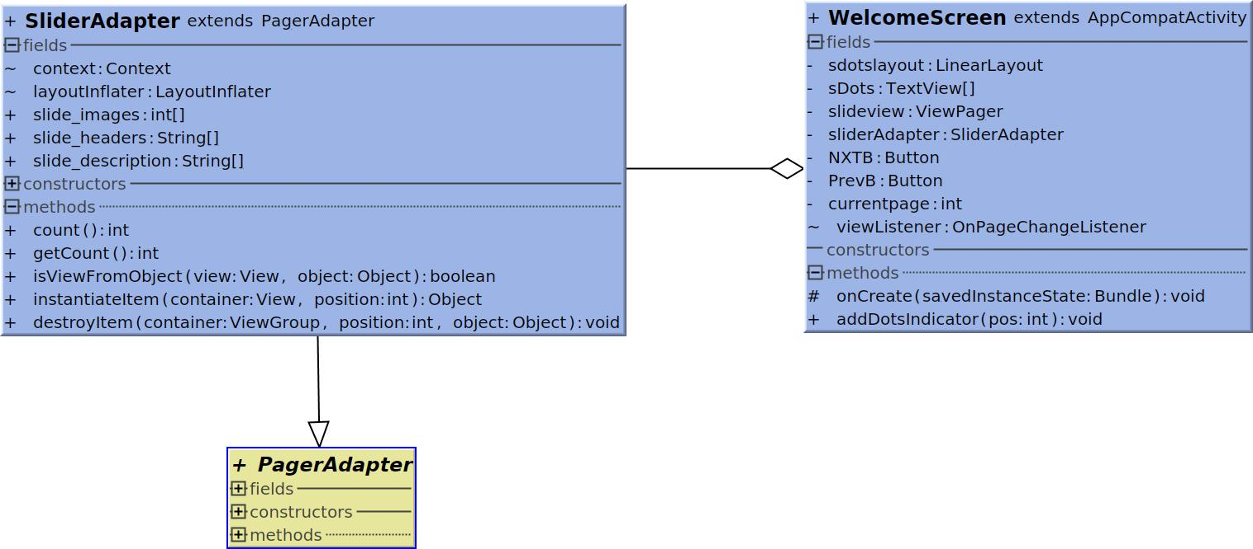Figure x: Class diagram for Welcome Screen

SliderAdapter is a subclass that inherits Pager Adapter, the class allow the creation of many screens using only one xml file and make the process of moving from one screen to another very simple and smooth.

WelcomeScreen is called after finishing the registration process it inflates the layout which contains the layout provided by SliderAdapter and add the buttons and the dots at the bottom. Figures x+1 and x+2 shows two of the welcome screens.

 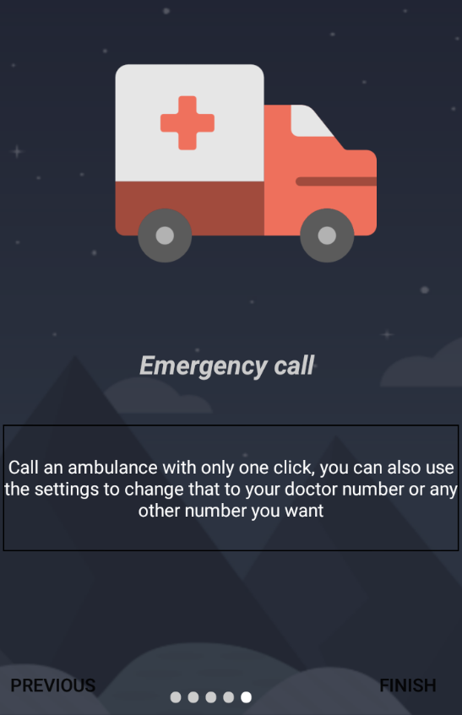

Figure x+1: Second welcome screen Figure x+2: Last welcome screen